**YUHUA SECONDARY SCHOOL**

**Subject Combination Option User Guide for Express Students**

**URL: https://yuhua.schoolhub.sg**

## Log in

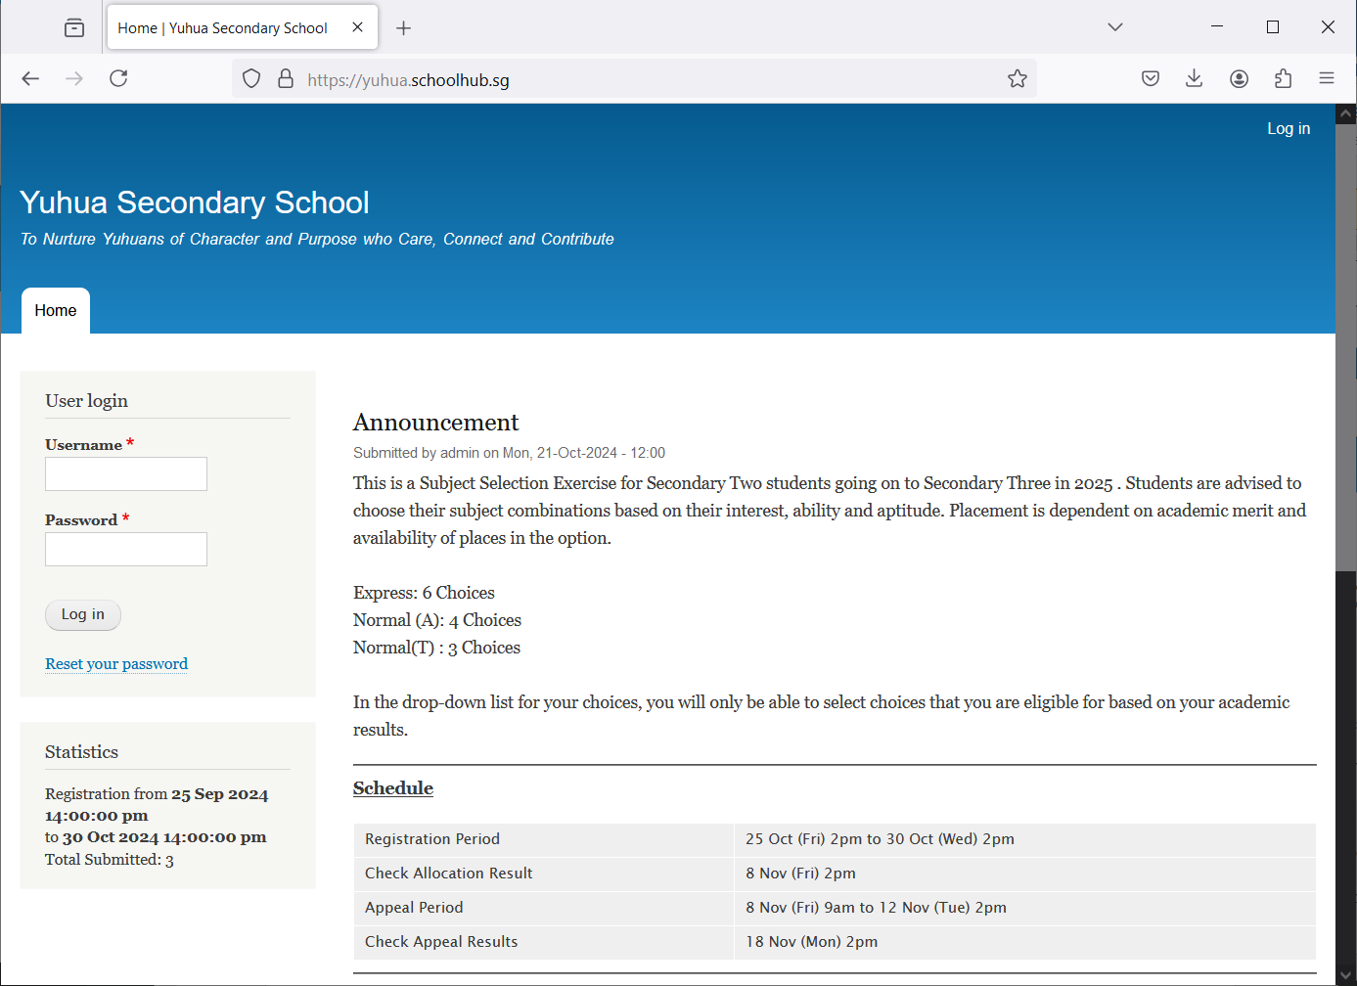

Steps

* Enter Username
* Enter Password
* Click on Log in button

## Main Menu

Upon Successful login, you will see the main menu

Update your Account

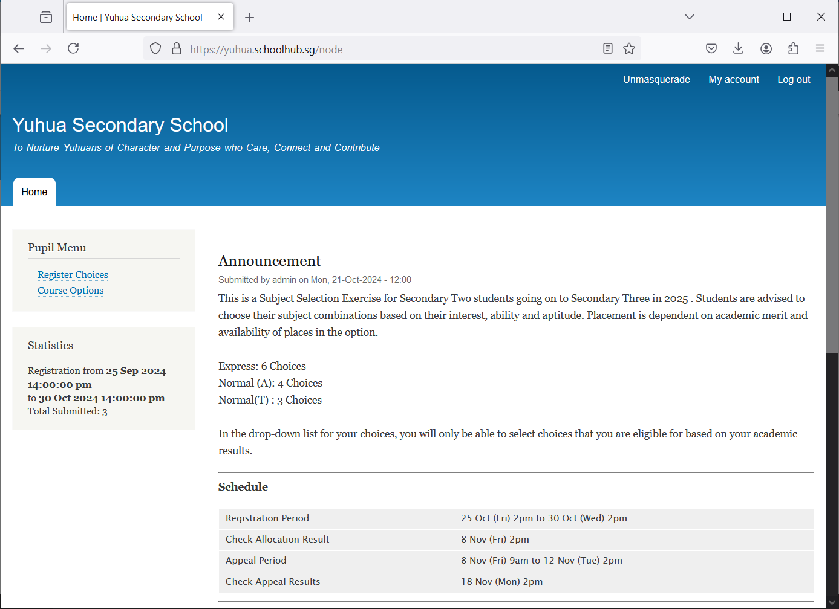

View all Subject Combinations

Update your choices

All Announcements will be posted here.

Send eMail if you have issue

## Update User Account

You may change your password and update your eMail before you proceed to your Subject Combination choices.

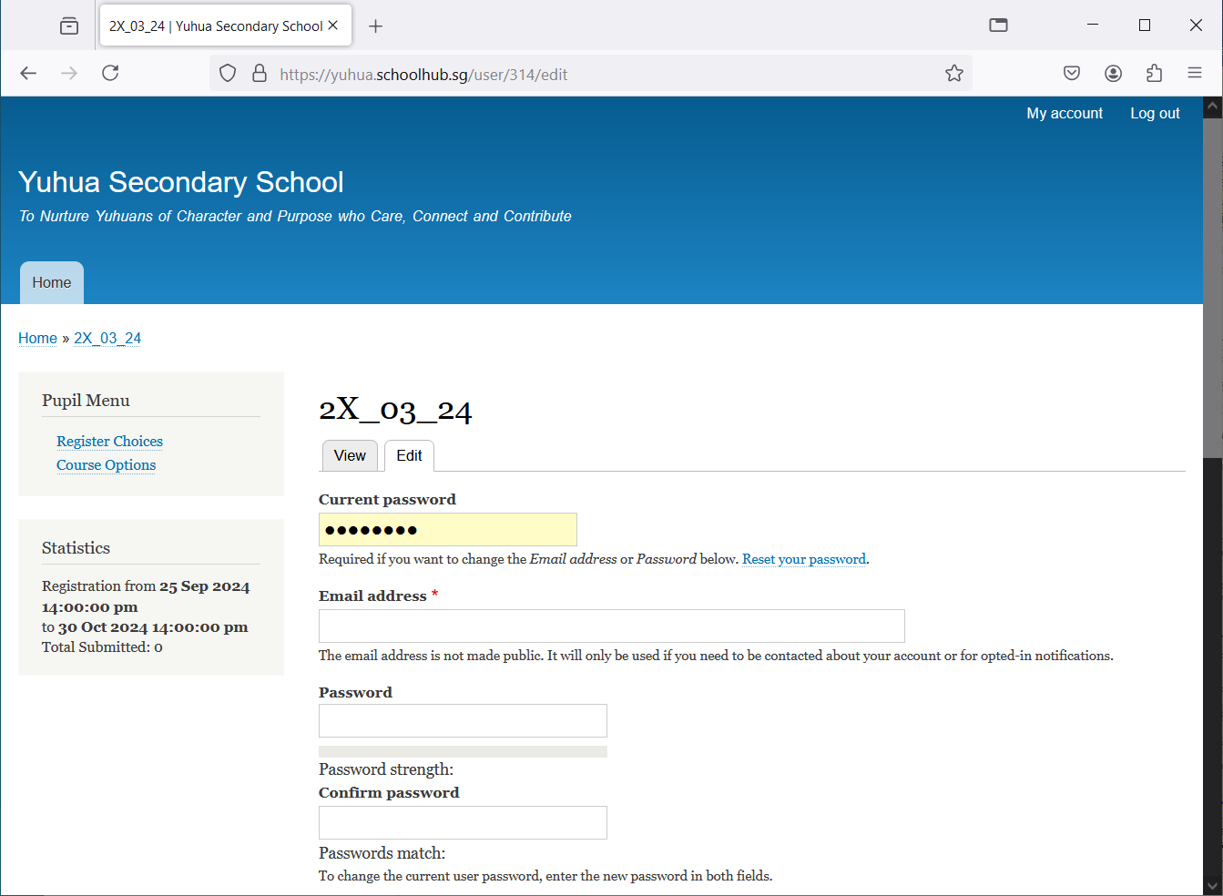

Steps

* Enter current password
* Update eMail Address
* Enter New Password (leave blank if you want to retain current password)
* Click on Save button

## View Streaming Options

You will be able to see the different Subject Combinations based on your Stream.

View Subject Combinations

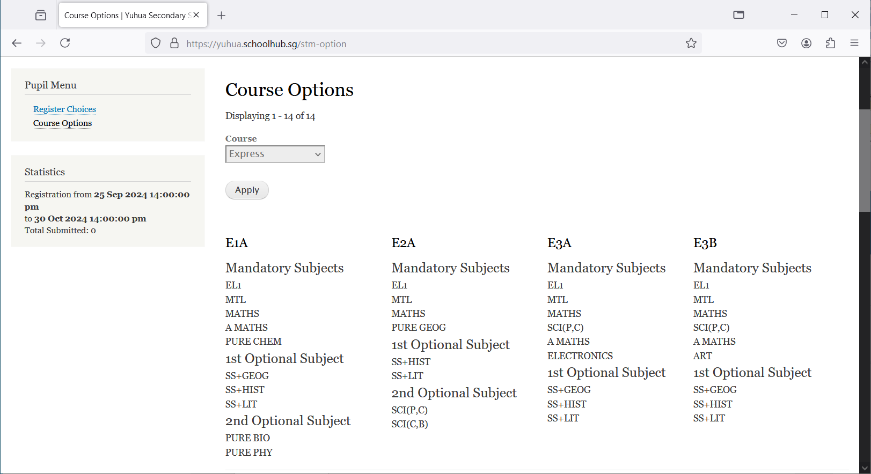

## Registration of Choices

These are the list of Options you may choose from

Mover-Over to view the Subjects in the Option

Register your choices

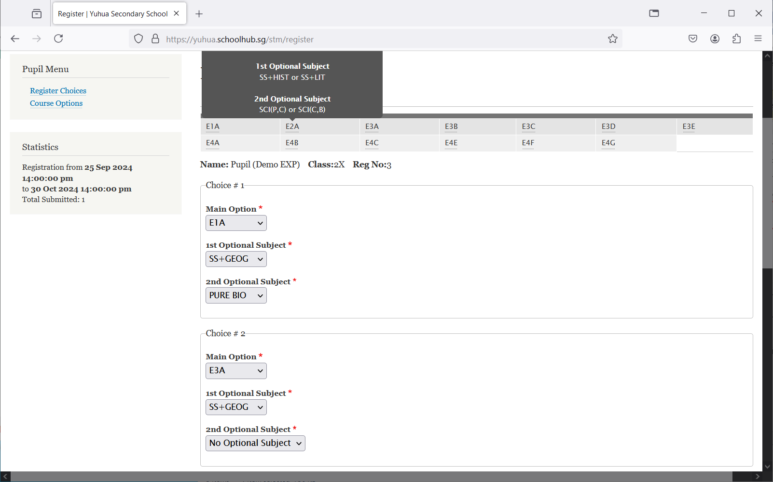

Enter all your choices

Steps

* Click on Student Option
* Update Your choices
* Click Submit at end of screen

Note:

You may change your choices any time before the closing date.

## 

## Print Confirmation Slip

Once you have Submit Successfully, you may proceed to Print the Confirmation Slip.

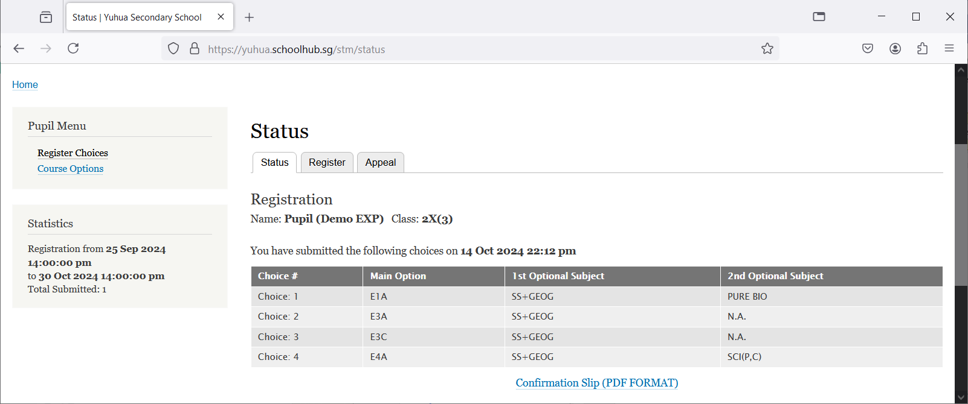

Steps

Print Confirmation Slip

* Click on Print Confirmation Slip (PDF Format)
* The hard copy confirmation slip must be signed and filled in with a contact number before submitting to General Office

**Sample Confirmation Slip**

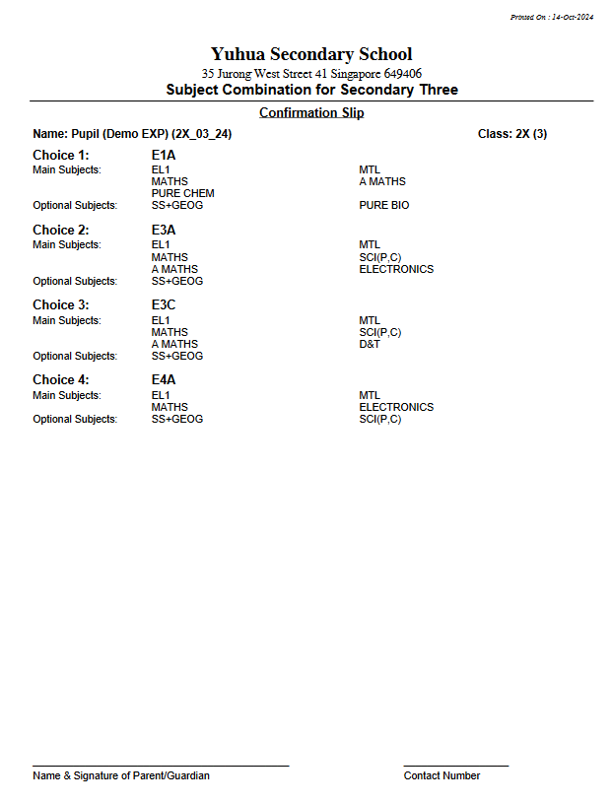

**Check Allocation**

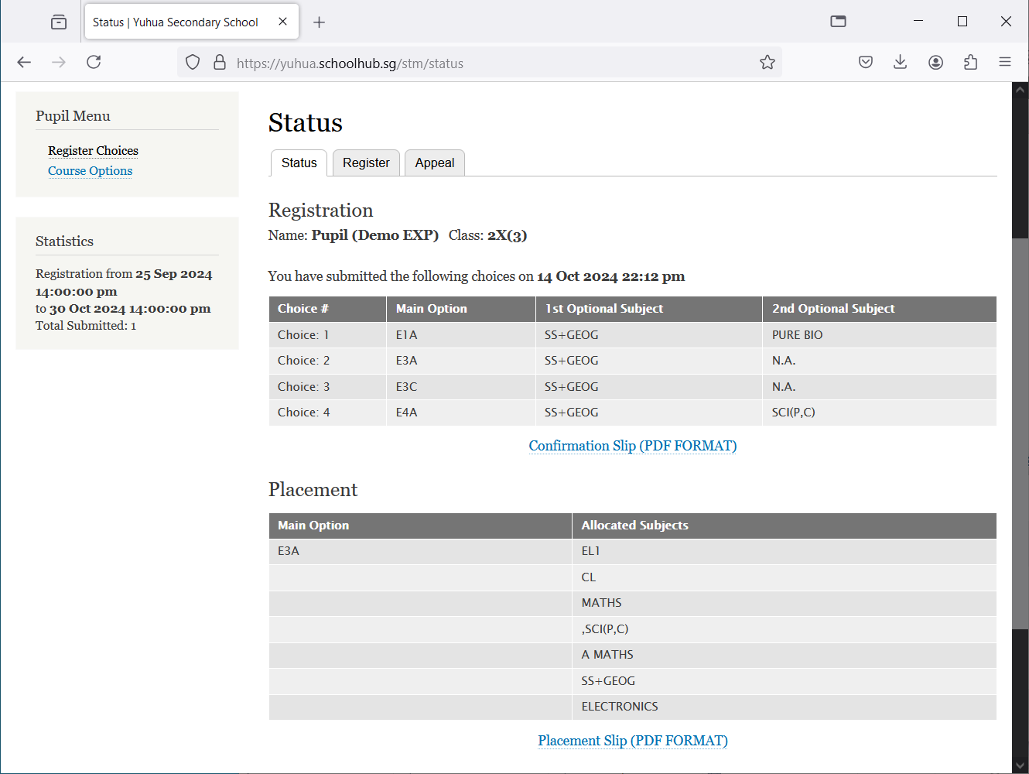

Print for your own reference

Allocated Subjects

**Appeal**

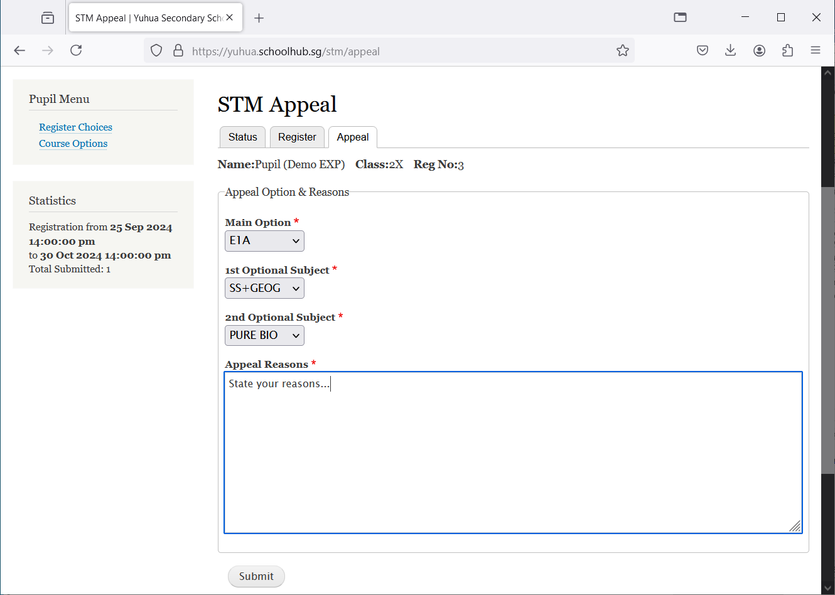

Steps

* Select the Option to Appeal
* Elect Optional Subjects
* Click Submit

Allocated Subjects after Appeal

## Check Appeal

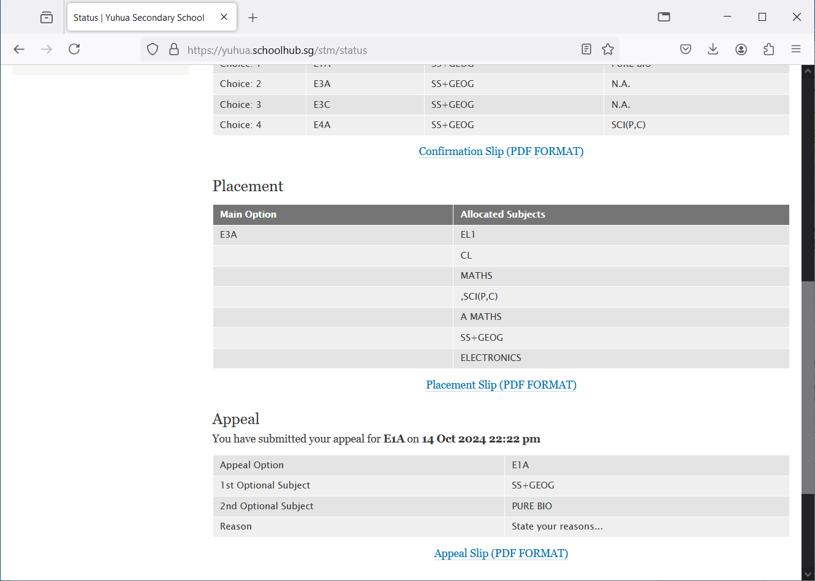

If your appeal is successfully, it will be updated here.

Response for your appeal